**Deploying ELK Stack on Docker Container**

**Project objective:**

You have to deploy ELK Stack on a Docker container to implement continuous monitoring.

Your manager has asked to create an elegant user interface for data analysis and data visualization as you have worked on ELK stack previously and have the idea of how it works. This will help the DevOps team to monitor and analyze the application behavior.

**Projects Requirements:-**

* Docker: To create a container for installing ELK Stack
* ELK Stack: To implement continuous monitoring
* Git: To connect and push files from the local system to GitHub
* GitHub: To store the Angular application

**Following requirements should be met:**

* A few of the source code should be tracked on GitHub repositories. You need to document the tracked files that are ignored during the final push to the GitHub repository.
* Submission of your GitHub repository link is mandatory. In order to track your task, you need to share the link of the repository in the document.
* The step-by-step process involved in completing this task should be documented.

**Screenshots:-**

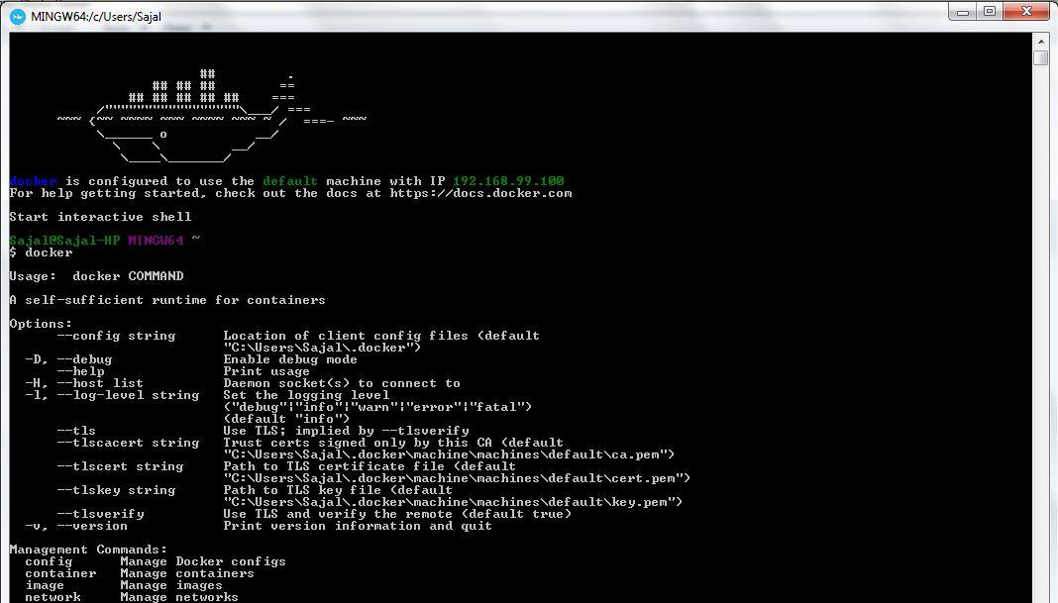https://i2.wp.com/howtodoinjava.com/wp-content/uploads/2017/08/17-1.jpg?resize=1066%2C57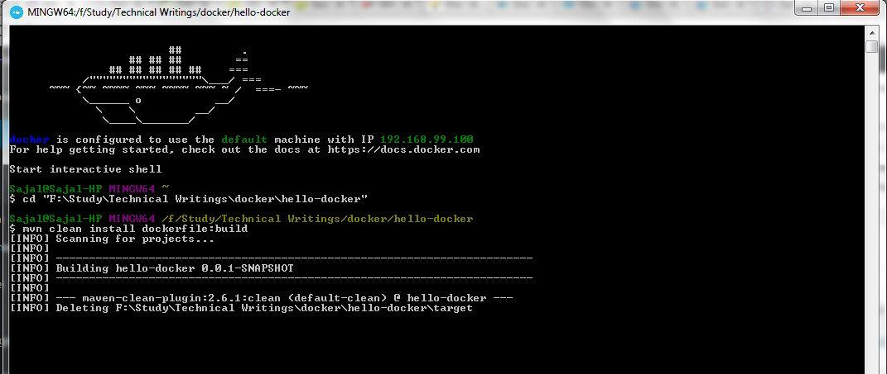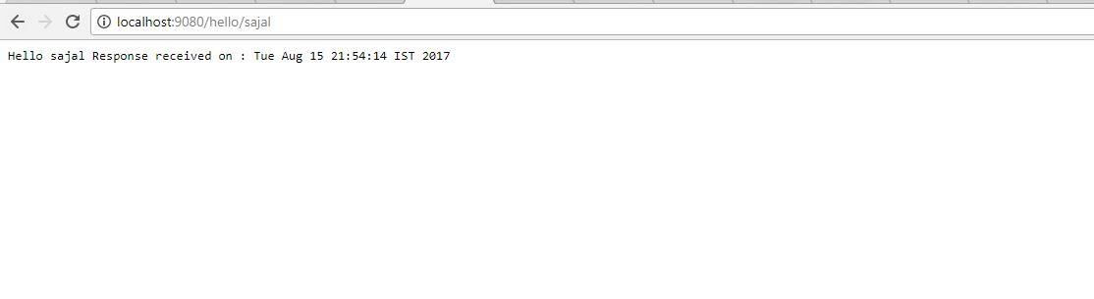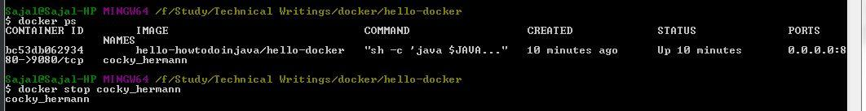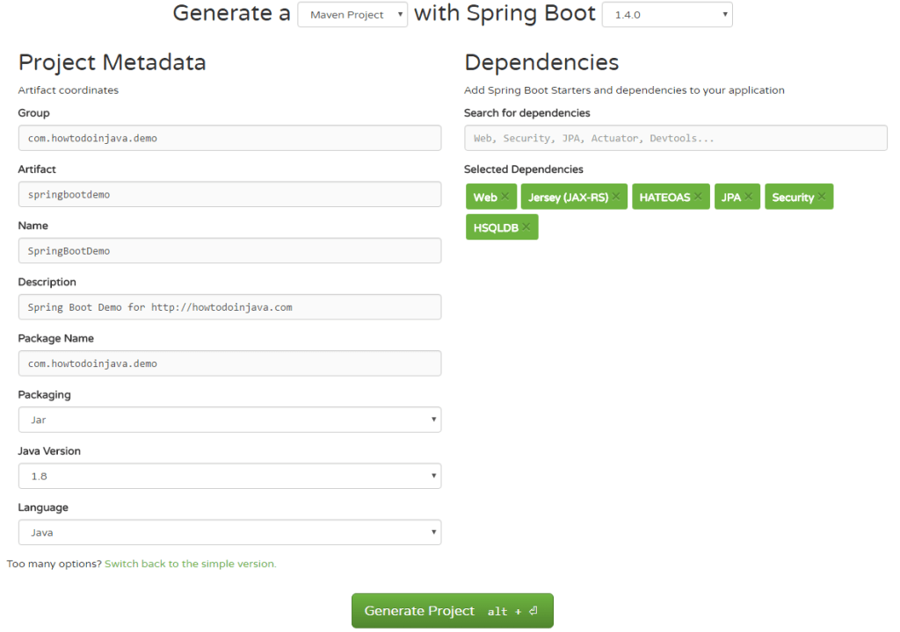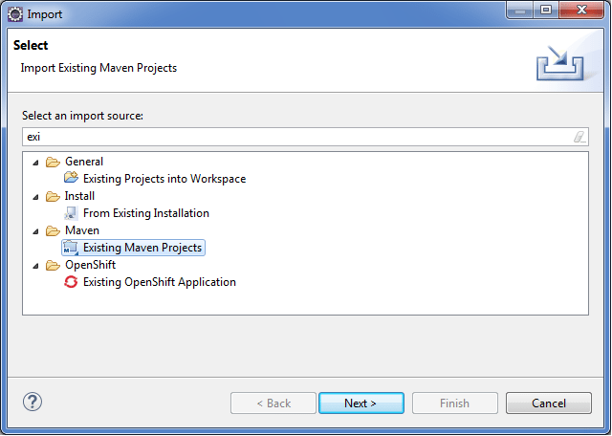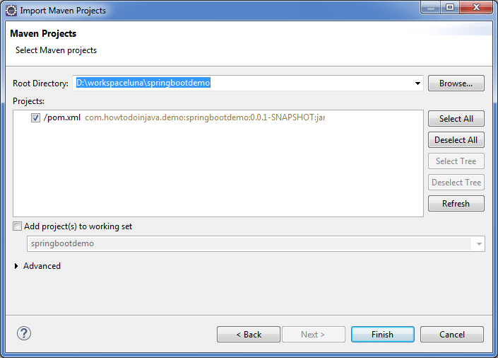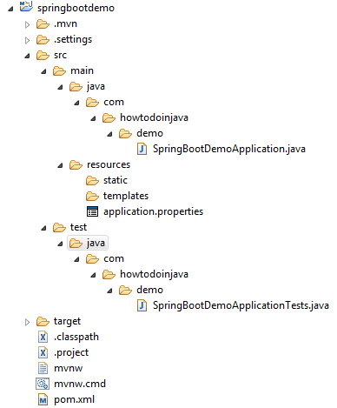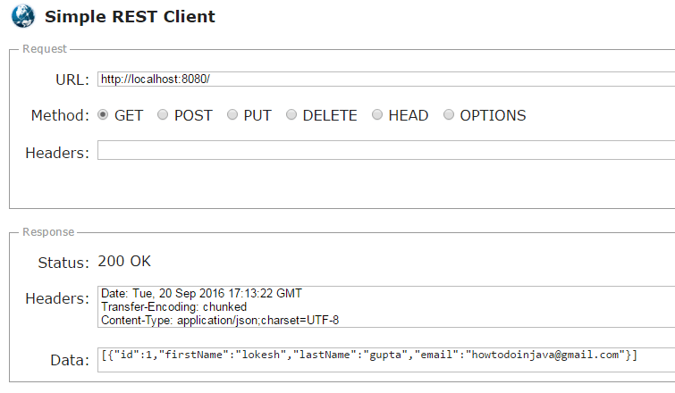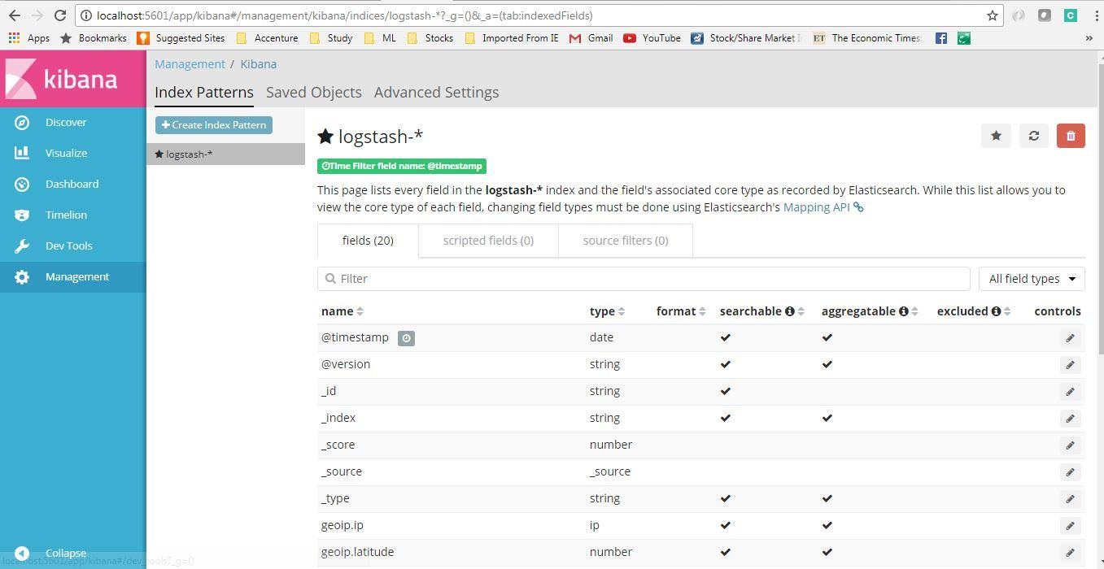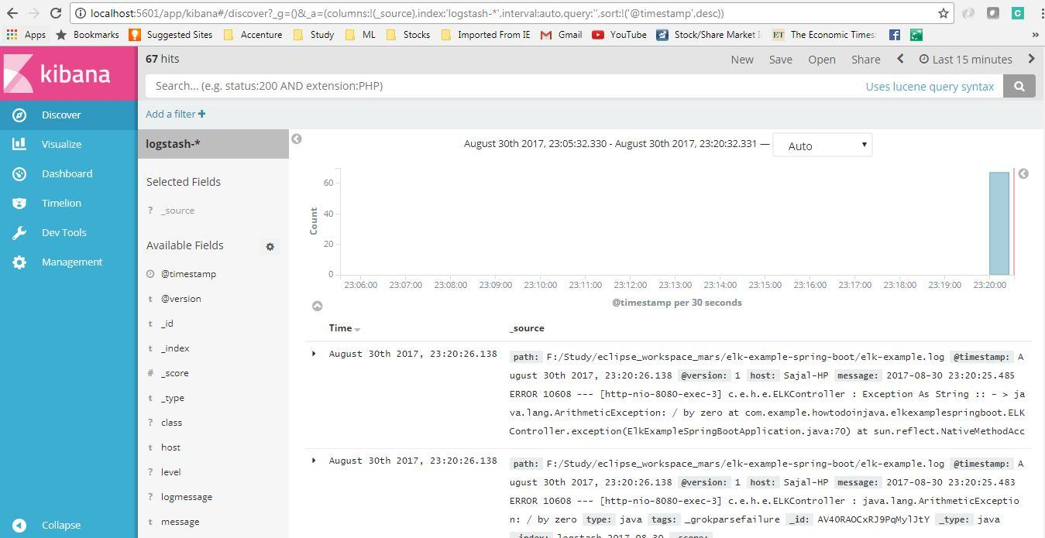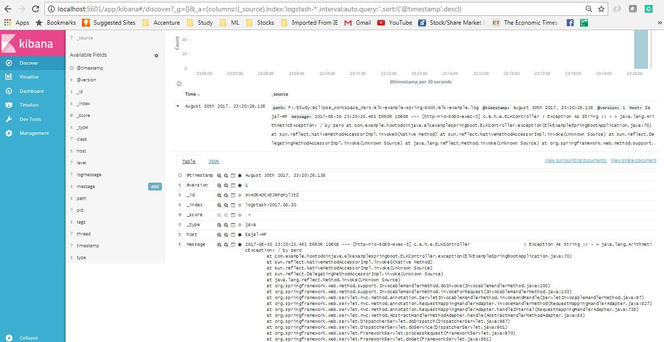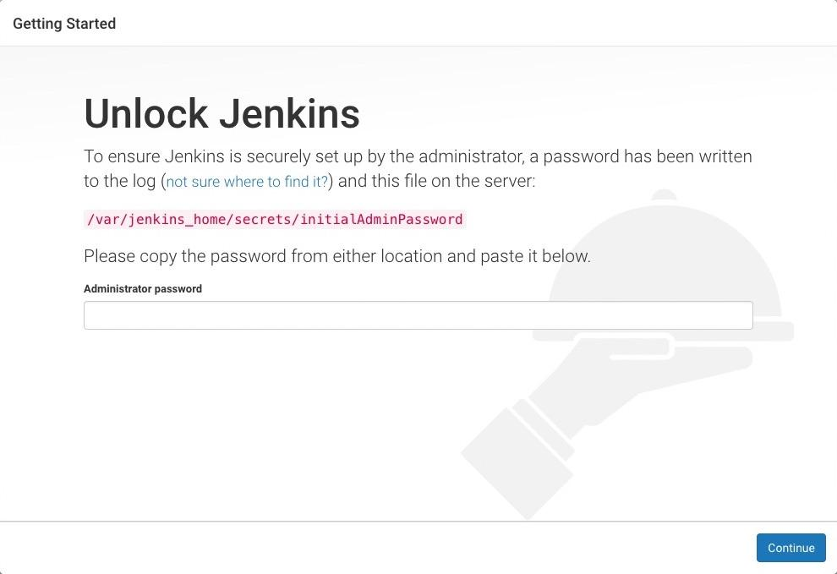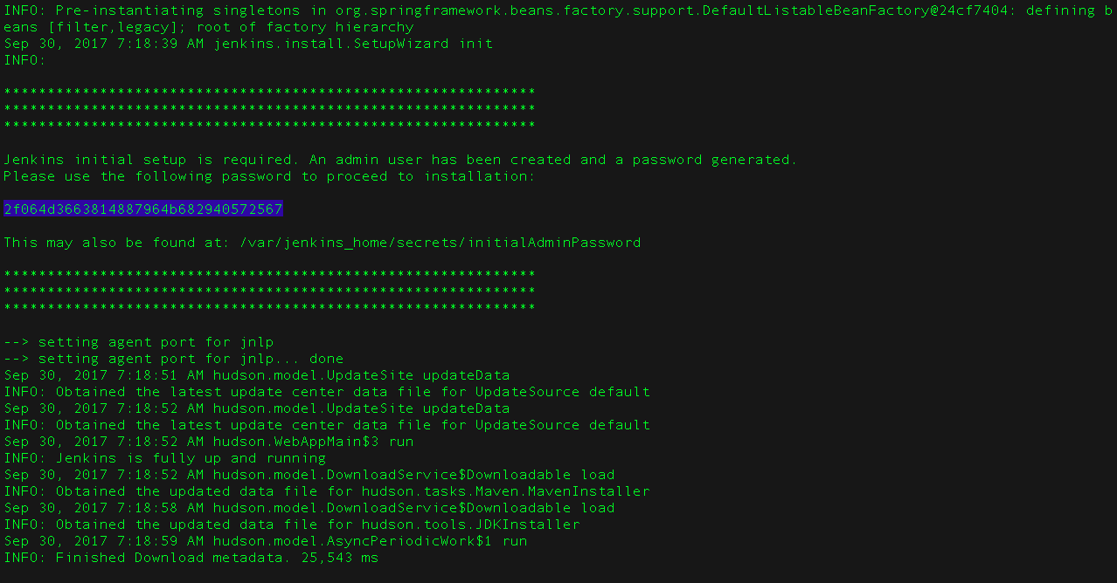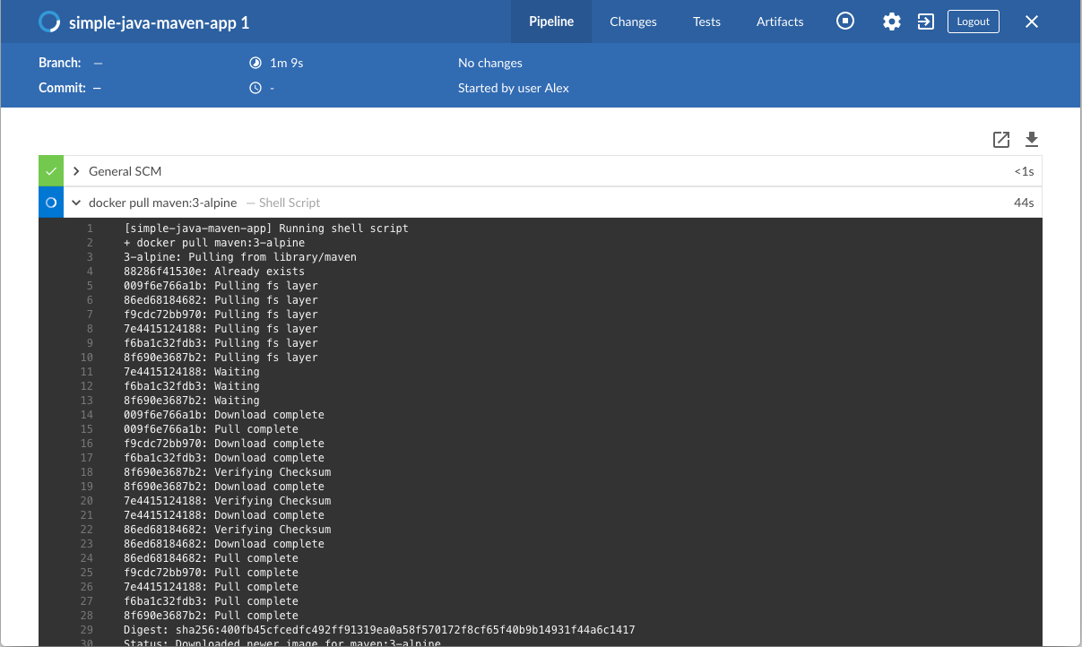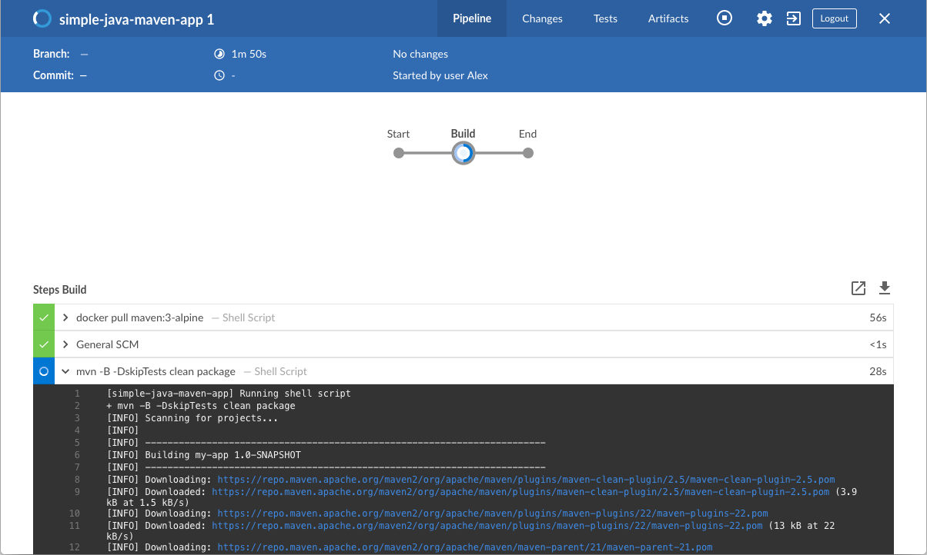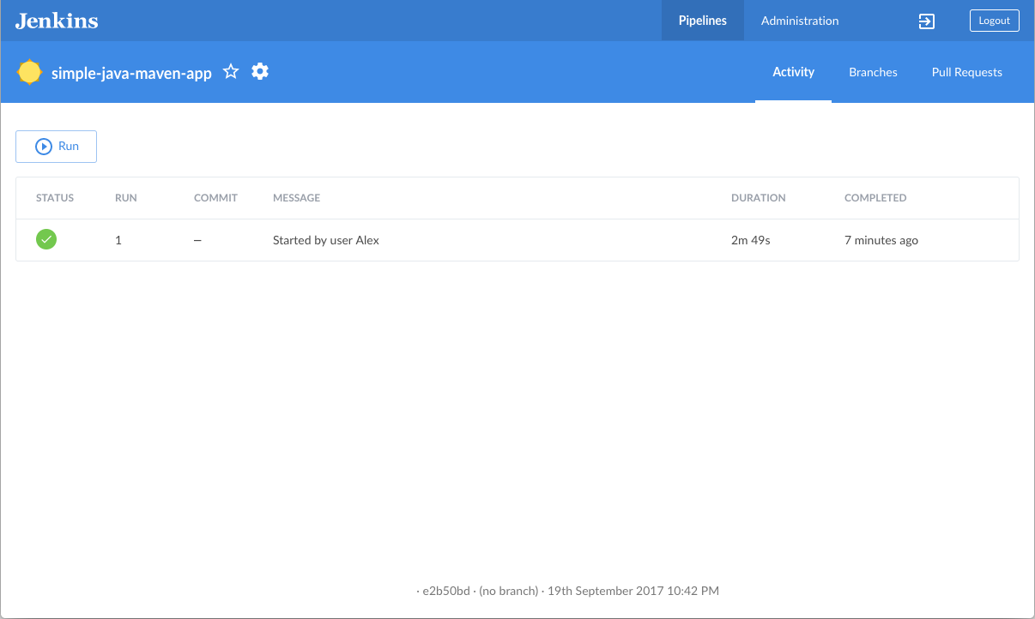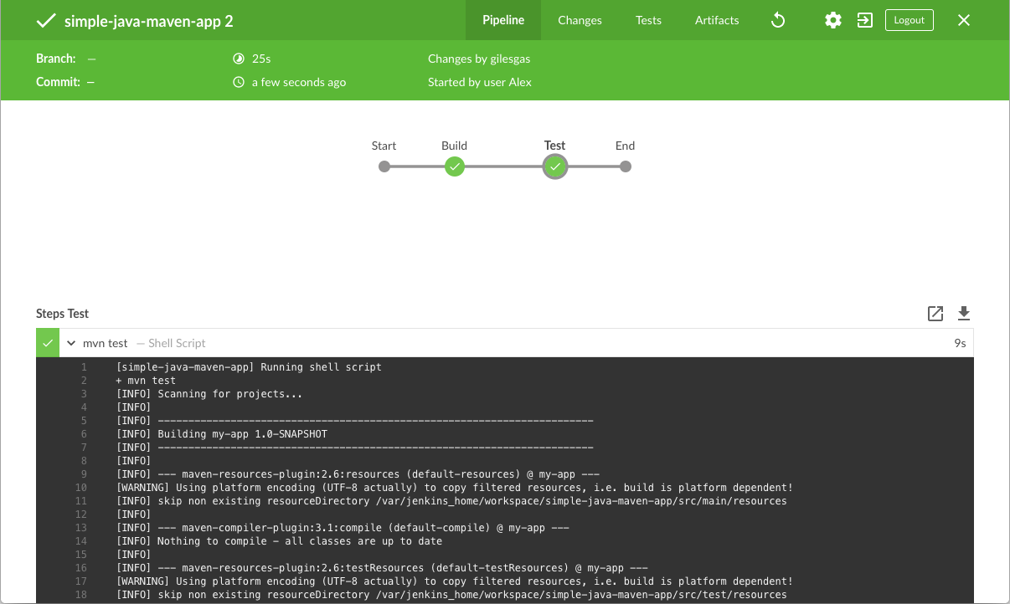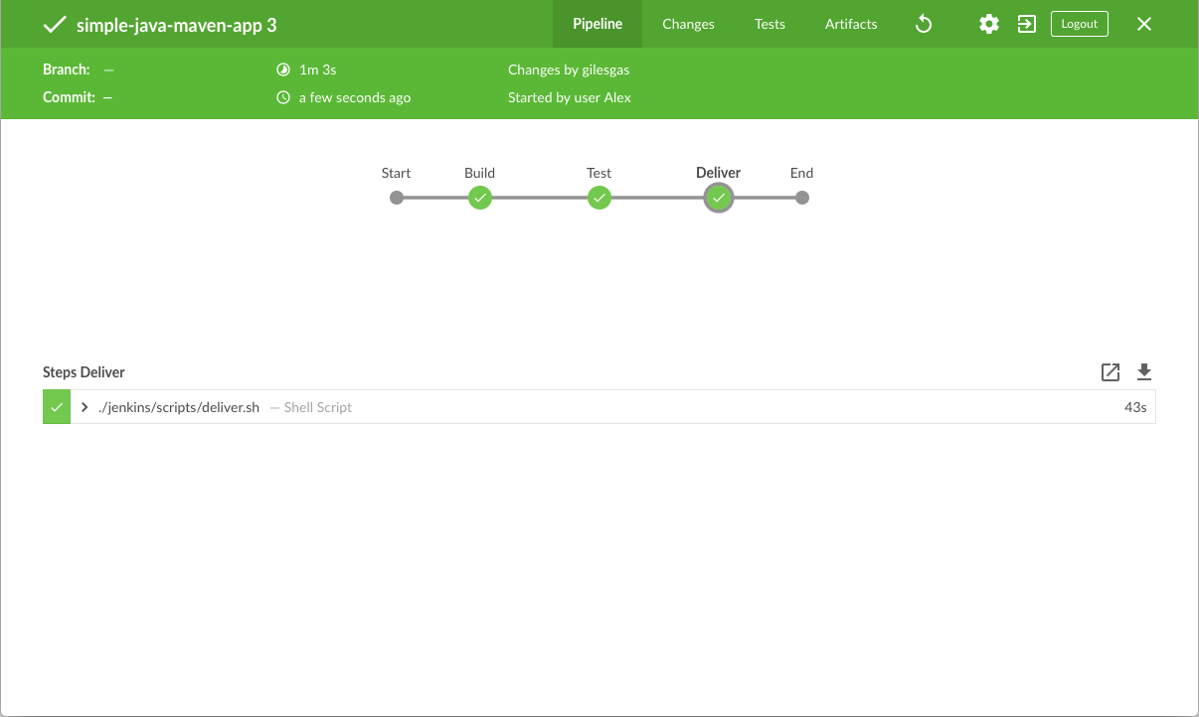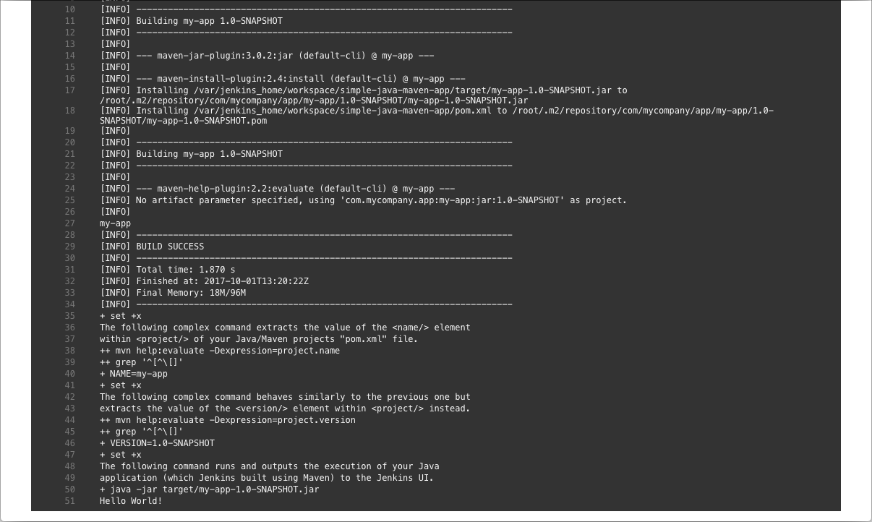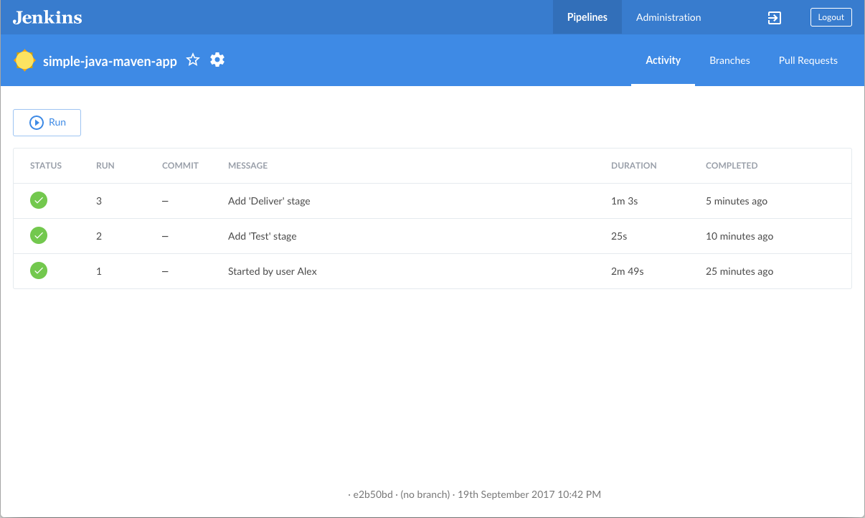

## **Pushing the code to GitHub repository:-**

* Open your command prompt and navigate to the folder where you have created your files.

**cd <folder path>**

* Initialize repository using the following command:

**git init**

* Add all the files to your git repository using the following command:

**git add .**

* Commit the changes using the following command:

**git commit . -m <commit message>**

* Push the files to the folder you initially created using the following command:

**git push -u origin master**